Lilleshall Parish Council  www.lilleshallpc.org.uk  Chairman: Cllr B Taylor  Vice Chair: Cllr C Binnington |  | Locum Clerk:  Mr C Furnival  01952 676 379  lilleshallparishcouncil@gmail.com

MINUTES OF THE FULL COUNCIL MEETING HELD 12TH DECEMBER 2023
HILLSIDE MEETING ROOM, LILLESHALL, 7PM

Members present Cllrs: Shaw, Harvey, Binnington, Parker and Taylor.
In attendance: Mr Furnival (Locum Clerk), Mrs K Goodwin (Admin Assistant), Cllr A Eade (Telford & Wrekin Council), PCSO Wills and PCSO Collumbell (West Merica Police) and five members of the public.

112/23 Election of a Chairman

It was RESOLVED that Cllr Bob Taylor is elected to serve as Chairman of the Parish Council for the remainder of the 2023/24 municipal year.

113/23 Acceptance of Office of Chairman

Cllr Bob Taylor read and signed the declaration of acceptance of office in presence of the Proper Officer. On behalf of the Parish Council Cllr Bob Taylor thanked Cllr David Shaw for his time as Chairman.

114/23 Election of a Vice Chairman

It was RESOLVED that Cllr Carol Binnington is elected to serve as Vice Chairman of the Parish Council for the remainder of the municipal year.

115/23 Acceptance of Office of Vice Chairman

Cllr Carol Binnington read and signed the declaration of acceptance of office in presence of the Proper Officer.

116/23 Apologies and declarations of Interest

Apologies from Cllr Challinor and Hoof due to work commitments.

117/23 Public Session

As a member of the public wished to discuss the A518, members agreed to discuss item 126 to allow members of the public to contribute to the discussion.

Cllr David Shaw reported that the Speed Improvement Devices (SIDs) have been installed and the issue of charging batteries has been addressed. The Locum Clerk said that GN groundworks have delivered Nal sockets / poles for the SIDS and are stored in the garage. Cllr Andrew Eade asked if a mirror has been installed on Church Road, and Cllr David Shaw confirmed that it hadn’t as yet. Cllr Andrew Eade said there is still work to be done on Barrack Lane and a 30mph sign still needs to be put up near the Red House. Cllr Andrew Eade has met with the Chief Executive at Telford and Wrekin about the scheme and has picked up numerous emails regarding complaints about highways. Cllr Andrew Eade said it was a question of appointing contractors, which is the task of Telford and Wrekin.

Cllr Andrew Eade agreed to use his Councillors Pride Fund to pay for a left turn sign for Brockton Leasows.

A member of the public expressed frustrations about the delay to the A518 scheme. Cllr Andrew Eade explained to the member of the public it was a matter of capacity at Telford and Wrekin. The member of the public wanted clarity about the proposals for this scheme. Cllr Andrew Eade addressed the public concern by stating that the Highways Authority has ultimate responsibility for road safety, but Lilleshall Parish has been proactive with the purchase of two SIDs. The Parish Council can put pressure on Borough Council but cannot complete the work on the highway’s authority land. Cllr David Shaw and Cllr Andrew Eade expressed concern that this situation will get worse with future development. A discussion was held regarding the possible siting of a SID near Brockton Leasows off the A518 but members were unclear on the possibility and management of this. Further investigation will be required.

Cllr Andrew Eade gave an update on speed humps in and around the Humbers. He paid for them from last years and this years Councillors Pride Funding. Plans are now being drawn up and the consultation is expected in the new year.

118/23 Lilleshall 5k 2024

Mr J Beyer of the Lilleshall and Muxton Scouts Group thanked the Council for an invitation to this meeting and explained that the group have taken over the management of the Lilleshall 5k in conjunction with the Newport Runners. The route will be similar to the route run for 10 years pre Covid, with the school and the church collaborating in the event. No road closures will be needed, and Mr. Beyer will send a link for the route to the Parish Council. PSCO Collumbell requested to be copied into emails regarding this. The proposed date of the Lilleshall 5k will be 28th April 2024. In addition to the 5k there will be a Junior Fun Run and a lap of the field for the very little ones, along with a BBQ and scout activities.

It was RESOLVED that a portion of the Parish Council small grant fund be used to buy medals for the event. The Locum Clerk requested that Mr Beyer submits a quote for the medals to the Parish Council so that it can be included in the budget.

Cllr David Shaw asked Mr Beyer about the scouts helping to plant trees around the Parish. Mr Beyer agreed in principle. Mr Beyer asked about parking next to the allotments and was advised to contact Telford and Wrekin about permission to park there. Cllr Andrew Eade advised him to email Dean Sargeant and copy it to Cllr Andrew Eade.

119/23 Minutes of the last Council meetings

The minutes of the last meeting held on the 14th November 2023 were RESOLVED to be accepted as a true record.
The following minutes will be deferred to the next meeting until the detail can be clarified: Extraordinary Full Council meeting 24th October 2023

120/23 Matters arising, for information, from the minutes
None.
121/23 Correspondence
West Mercia Police & Crime Commissioners Safer Roads Fund – Cllr Andrew Eade requested Locum Clerk send him copy of it and that this item is put on the January agenda.
122/23 Reports from Parish Councillors and Ward Member present

None

123/23 Clerks Report
DB Seabury has been instructed to maintain SID batteries. We will need to purchase another battery to ensure effective operation of both SIDs. The Locum Clerk has purchased a new printer for the Parish Office.
The defibrillator cabinets outside the Youth centre and the Humbers Stores need to be replaced. Local first responders raised an issue regarding the condition of the named cabinets. The approximate cost to replace the cabinet is £600 per cabinet. The Locum Clerk wanted the Parish Council to note that they will need replacing in the next financial year and should be considered in the budget.
It was agreed that the tree guards are kept in storage until the next financial year, when a suitable project is agreed.
124/23 Community Governance Review
The Locum Clerk confirmed that he has submitted the Parish Councils position to Telford & Wrekin Council. There were no further updates at this time.
125/23 Local Plan Review 2023

There is a public drop-in session arranged for Friday 15th December 2023, from 3:30pm to 6:30pm. Leaflets have been distributed to the whole Parish and displayed online and on noticeboards. Thank you to councillors and staff who distributed the leaflets around the Parish. Councillors expressed concern about the capacity of current infrastructure, flood risk, the sustainability of the project and the impact on local farmers and food production. Cllr David Shaw suggested that a consultant is contracted along with a working group to focus on this issue. The former MoD site is planned to have approximately 250 houses and Cllr David Shaw suggested that we support this part of the Local Plan.

20:06 – Cllr. David Shaw left the meeting.

126/23 Road Safety Scheme and A518

On the 5th December 2023 Telford & Wrekin Council were instructed to complete the remainder of the road safety scheme with the matter of the final billing to be addressed with them at a later date.

123/23 Planning

Members considered the following planning applications and RESOLVED to approve the following comments;
Planning Application Number, Location & Proposed Development | LPC Response
TWC/2023/0872 - Sundawn, 13 Limekiln Lane, Lilleshall, Newport, Shropshire, TF10 9EY  Erection of a two bedroom annexe with double garage | No comment

The following applications that had been decided since the last meeting of the Council where noted;

Planning Application Number, Location & Proposed Development | LPC Response | Decision
TWC/2023/0795 - Abbey View, Church Road, Lilleshall, Newport, Shropshire, TF10 9HJ  Erection of an annexe building | No comment | Granted
TWC/2023/0641 - Jardwood Farm, Kynnersley Drive, Lilleshall, Newport, TF10 9HT  Construction of 4no. carports and revised landscaping, parking and access in relation to planning permission TWC/2020/1107 (Conversion of agricultural buildings into 4no. dwellings) | No comment | Withdrawn

  - 127/23 Financial Reports

Members reviewed the latest bank reconciliation up to 30th November 2023, bringing the accounts to a balance of £101,514.31 and the payments made since the last meeting and their corresponding invoices/receipts.

Members RESOLVED to accept the bank reconciliation as an accurate report and approved the list of payments made:

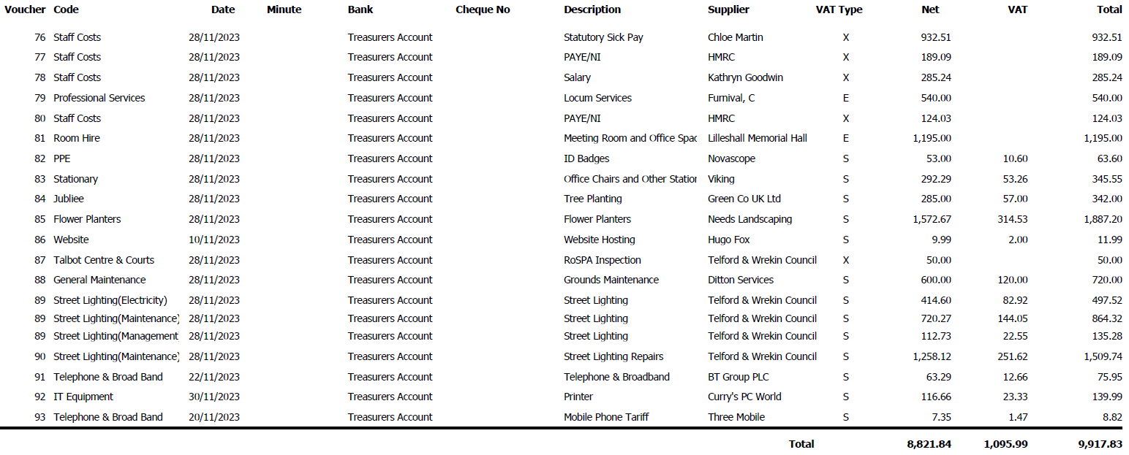

The Locum Clerk stated that the budget will be discussed in the January meeting.

Cllr Carol Binnington expressed thanks to the Locum Clerk and Admin Assistant for their hard work.

20:20. Cllr Andrew Eade left the room along with the PCSOs and all public.

128/23 Exclusion of Press and Public

It was RESOLVED that in accordance with section 1(2) of the Public Bodies (admissions to Meetings) Act 1960,
and as extended by Schedule 12A of the Local Government Act 1972, the public, including the press, be excluded from the meeting because of the confidential nature of the business to be transacted.

The Locum Clerk informed members of the notice of resignation of the former Clerk, noting that the period of notice ends on the 8th January 2024.

Members RESOLVED to delegate it to the Locum Clerk to prepare the job advertisement, job description and application forms to the Locum Clerk who will begin the advertising process and make arrangements for the Personnel Committee to meet formally to review applications and arrange interviews for the appointment of a new Clerk. Advertisement will be issued on the 13th December 2023 with a deadline for applications by the 10th January 2024. The Personnel Committee will meet the week of 15th January 2024. The interviews will be conducted in the week commencing 22nd January 2024.

Members confirmed that during the period of employing a Locum Clerk, the office hours will be advertised as Tuesdays between 9:30am to 12pm and 1pm to 3:30pm to allow staff the opportunity to deal with important work and still maintain a level of drop-in availability to the public. Once a new Clerk is employed then arrangements for advertising of office open hours and appointment times will be updated.

Members considered the quotes received and RESOLVED to accept the quote for the installation of a new heating system at The Talbot Centre and instruct DH Electrical to commission these works

Cllr Carol Binnington proposed that an earlier start time of 6.30pm should be an item on the agenda at the next Full Council Meeting in January.

This meeting closed at 20:43
These minutes are to be considered as a draft form until signed at the next appropriate meeting, the signed copy will be retained by the Parish Council.

Signed: …………………………………… Dated: ………/………/………

Date of future meetings
Full Council, Tuesday 9th January 2024, 7pm at Hillside Meeting Room

